No Redwood Is an Island
by Kate Chandler, Associate Professor of English

“So many days, spent outside the town, trying to hear what was in the wind...”—Thoreau

Turning to the natural world for thrills or solace or joy or relaxation is typical. We are drawn outdoors for activities and amusements of many kinds. Do we, however, turn to nature for models of social organization and behavior? I have learned of one we ought to consider.

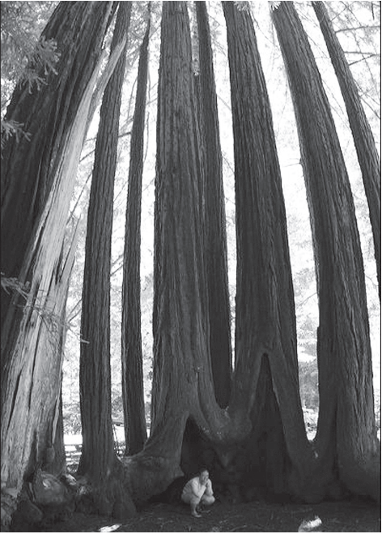
Each tranquilly majestic tree appears sufficient unto itself, but these redwoods actually draw strength from each other.
Photo by Eric Heisler ’00
Trapped on the phone one recent day, I occupied myself by studying our woods. I examined the forest
to the left of the path, then to the right. That was when I saw them: five precipitously leaning pine trees.

Five trees falling right next to each other. As dense as this young forest is, I thought that neighboring trees would help all to remain upright, if not by joining root systems then by holding each other up since their trunks are barely a foot apart. Shoeless, I charged out the front door, portable phone in hand, and inspected from the porch edge. It appeared as if one more vigorous spring rain, and the trees would topple. A neighboring loblolly pine was already down with its root ball perpendicular to the ground.

How had I not seen these before? I regularly tramp through our woods searching for the young shade-loving oaks and hollies that have been sprouting beneath the towering pines. I also look
for leaning trees but, somehow, had not noticed these. They had to have loosened suddenly, probably in a late winter downpour, and they appeared certain to join their horizontal neighbor. Appendix #1C1

Examining the downed loblolly, I was astonished by the disproportionate smallness of the root ball. The tree had been young but tall. I stepped its length: over 20 feet, as high as many two-story houses. In comparison, the clump of roots looked diminutive, only 14 inches in diameter. Except for a miniscule taproot, ten and a half inches long (less than a ruler!), the roots extended only seven inches. The entire underground mass looked about the size of a common throw pillow.

Since I knew from my tree books that shallow root systems often spread out to a distance that matches the tree’s height, the miniscule diameter of these pine roots was startling. Such a small clump of roots hardly looked able to anchor a bush, much less a tree.

Now that I saw how undersized the roots were, I wondered why all of our pine trees hadn’t toppled. Then I thought back to Hurricane Isabel when both Route 5 in Maryland and 301 in Virginia had been shut down because of downed trees, mostly pines. On 301, collapsed pines blocking the road were so numerous they looked like pick-up sticks tossed in a heap.

As I dialed the telephone number of our local tree man to come and assess these dangerously leaning pines, I thought back to last August when my husband and I had visited the Pacific coast. What a contrast.

One foggy afternoon in northern California, as I strolled through the Lady Bird Johnson redwood grove, a man quietly came up alongside me and said, “I feel as if I am in a cathedral.” I did not even drop my gaze from the treetops as I returned, “So do I.” When I finally turned to greet him through the mist, I saw a man in a suit. He explained that he was reluctant to continue his drive to a meeting in San Francisco; this was the first time he had seen redwoods. I noticed that we both spoke in a hush and moved at the pace of a slow procession. Neither of us wanted to break the spell.

My business-suited companion also observed how few downed trees there were. There could have been any number of human reasons for that: harvesting dead trees by local hippies or general park service maintenance of the forest floor, but I had read in the trail guide that current policies recommended minimal intervention in order to let the forest evolve naturally.

In the brochure, I had read something else that intrigued me, and now, dialing the tree man in Maryland, I remembered it. The trail guide had explained how itis that Pacific storms do not knock over redwood trees. To live and remain upright, redwoods work together.
Then I recalled a Sunday talk I had heard explaining in more detail how redwoods’ roots literally reach out to others. The talk was later published and so impressed me that I had placed a copy in my “think about this” file. I located it. The piece was by Richard Winkel.

“The gigantic redwoods dwarf their other softwood and hardwood neighbors,” Winkel observed, “thus becoming ‘the Mount Everest of all living things,’ reigning over associated trees because of their
overwhelming height and majestic beauty.

“However,” he continued, “there is another feature of these towering giants that is truly remarkable and somewhat unknown to most of us. Even though they grow up to heights of 300 feet and can weigh more than one million pounds, these trees have a very shallow root system. Their roots only go down three to six feet but . . .”—and this is what differentiates them from our Maryland loblollies—redwood roots “can spread out several hundred feet.”

Winkel added that redwood roots not only spread a great distance, they also intertwine with those of other trees. “This intertwining of roots creates a webbing effect,” he wrote. “Most engineers would tell
you this shallow root system still would be impossible to keep the redwoods intact and protected against strong winds and floods.”

What the article concludes, however, points to a principle relevant to all of us, and one we may want to consider as we reflect in these Gazette pages about “community.” Winkel observed that “the inter-
connecting root systems are the secret of their strength and teach us a great lesson. . . these
magnificent giants simply could not make it alone.”

That lesson has me thinking about us at St. Mary’s College.

Are we loblollies? Or, are we redwoods?
http://www.smcm.edu/rivergazette/_assets/PDF/may07/may07/naturenotes.pdf

Appendix #1C2

